Vocabulary and Spelling Tests

Match the correct vocabulary word to its definition

A sulking ____ A celebration you have on a yearly basis.

B design ____ To be silent or grumpy because of disappointment.
C anniversary ____ A person who uses their creativity and skills in math and science to
solve problems for their community.
D structures ____ Any thing, system, or process that people create and use to solve a
problem.

E technology ____ A large building or creation that has a function.

F civil engineer ____ A plan that helps a person create something.

Word | Correction
1
2
3
4
5
6
7
8
9
10
Bonus
Final Paragraph Presentation

Directions: Use your rough draft that we created this week to write a final paragraph below. You will be graded for proper capitalization, punctuation, spelling, sentence structure, and presentation. Feel free to add your own voice to make the paragraph more interesting. Do your absolute best and I’ll see how ready you are for next week!

__________________

_________________________________________________________
_________________________________________________________
_________________________________________________________
_________________________________________________________
_________________________________________________________
_________________________________________________________
_________________________________________________________
_________________________________________________________
_________________________________________________________
_________________________________________________________
_________________________________________________________
_________________________________________________________
_________________________________________________________
_________________________________________________________
Add an illustration to add meaning to your paragraph.

Comprehension Test: Javier Builds a Bridge Part One

1. What are illustrations?
__________________________________________________________________________________________________________________
2. What does it mean to make an inference?
__________________________________________________________________________________________________________________
3. Which of the following is a character trait that best describes Javi?
a. annoying
b. wise
c. generous
d. energetic

4. Use your story to sequence the first three chapters of the story.

5. Make a meaningful prediction about what will happen in the coming chapters and explain why you think that with details from the story.
__________________________________________________________________________________________________________________
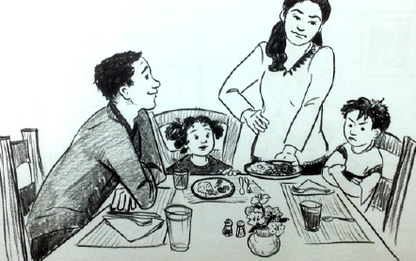 | 6. Which of the following inferences would you most likely make using observations from this picture?  a. Javi and Joe don’t like what is for dinner.  b. Luisa is teasing Javi and making him mad.  c. Javi and his mom are upset at each other.  d. Javi is apologizing to his parents.
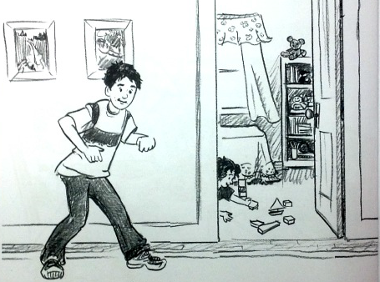 | 6. Which of the following inferences would you most likely make using observations from this picture?  a. Javi is dancing in the hallway.  b. Javi is trying to sneak in the hallway.  c. Luisa is setting a trap for Javi.  d. Javi is still mad at his family.
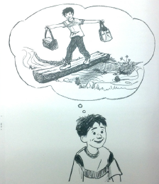 | 6. Which of the following inferences would you most likely make using observations from this picture?  a. Javi is excited about making a new bridge.  b. Javi is still mad that he will lose his bridge.  c. Javi is a lazy day dreamer.  d. Javi wants to carry things to his fort.
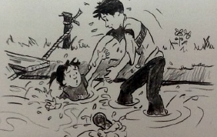 | 6. Which of the following inferences would you most likely make using observations from this picture?  a. Javi is trying to hold his sister under water.  b. Javi is trying to help his sister out of the water.  c. Javi and his sister are playing a water game.  d. Javi is very afraid of water.
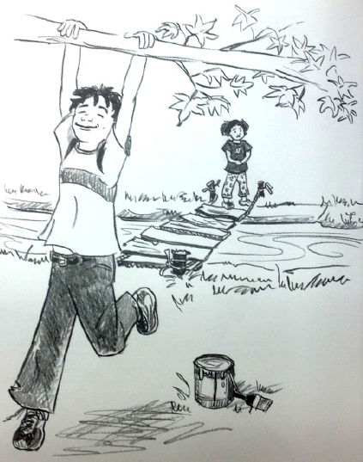 | 6. Which of the following inferences would you most likely make using observations from this picture?  a. Javi’s dad forgot his paint.  b. Javi isn’t afraid of anything.  c. Luisa is excited about going to the fort.  d. Luisa is nervous about crossing the bridge.

Division Skills Test
Writing Equations and Commutative Property Test
Objective:
I will be able solve division equations using two different strategies and identify the vocabulary terms of a division problem.
Solve the problems below with the sharing/splitting model. | Solve the following problems with the repeated subtraction model.
18 ÷ 3 = ____ | 60 ÷ 10 = ____
24 ÷ 6 = ____ | 30 ÷ 5 = ____
12 ÷ 4 = ____ | 25 ÷ 5 = ____
21 ÷ 7 = ____ | 20 ÷ 10 = ____
4 ÷ 4 = ____ | 15 ÷ 5 = ____

Identify the vocabulary terms for the following problem.
54 ÷ 6 = 9

